# CS 255 System Design Document Template

## UML Diagrams

### UML Use Case Diagram

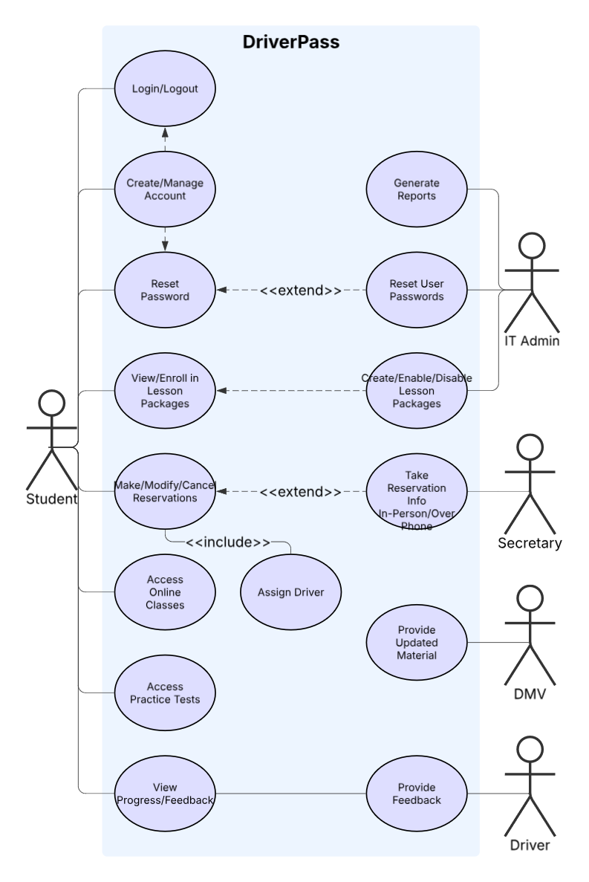

### UML Activity Diagrams

### 

### UML Sequence Diagram

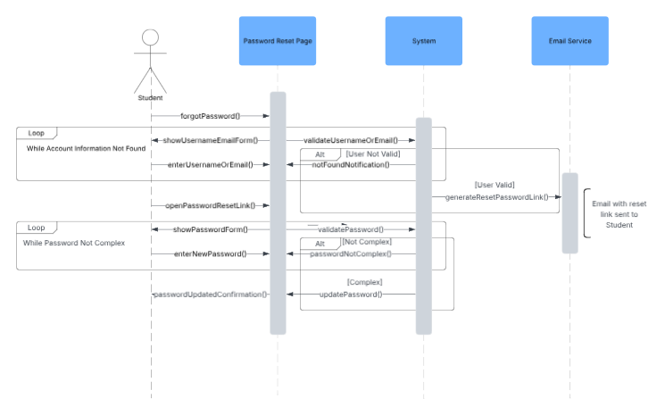

### UML Class Diagram

## Technical Requirements

*DriverPass* seeks to provide a plethora of resources to users seeking to pass their driving tests. To accomplish this, the system will need to be reliable, secure, and easy to use. The *DriverPass* system will run as a web-based application, supporting access from students, secretaries, and IT administrators. The system will need to be accessible from desktops and mobile devices.

The system will feature a client-server model. This model will ensure that the server and access to its contents stay consistent across multiple devices. This separation of concerns also enables client systems to be developed independent of the server, allowing greater flexibility when new client accessibility is added to the system.

In this system, clients will need to support modern web browsers and HTTPS communication in order to communicate with the server. The server side will need adequate storage for non-volatile files and resources, as well as a linked database for the purpose of storing data regarding such things as user account information, reservations, and lesson packages. Implementing a RESTful API for communication with the server would be the best practice to support multiple types of client systems. A Linux-based platform is recommended for implementation of the server, due to its open-source nature being cost effective as well as access to a wide range of server management, networking, and security features.

The server will also be deployed using a cloud-based service to ensure accessibility. This service will provide automatic backups of the system in case of system failure as well as access to server monitoring tools. This is critical for the IT administrator role who will need access to this information when monitoring and correcting system issues.

In terms of security, the transmission of data over HTTPS with TLS will ensure communications are secure and protected. User passwords and payment information should be secured and hashed within the server to prevent unauthorized access. Role-based action control (RBAC) will also be implemented to ensure users only have access to what they are permitted. System actions will also be logged and accessible by the IT administrator.